Let’s upgrade

Assignment Day 3

Question 1

1. Create a blank file named "myfile"

2. Open "myfile" in VI editor

3. Write your name, address, email id, phone number and blood group in 5 different lines

4. Build one single expression to see the line with your name and blood group in myfile

Answer 1.

Creating And Verifying myfile By Using touch command.

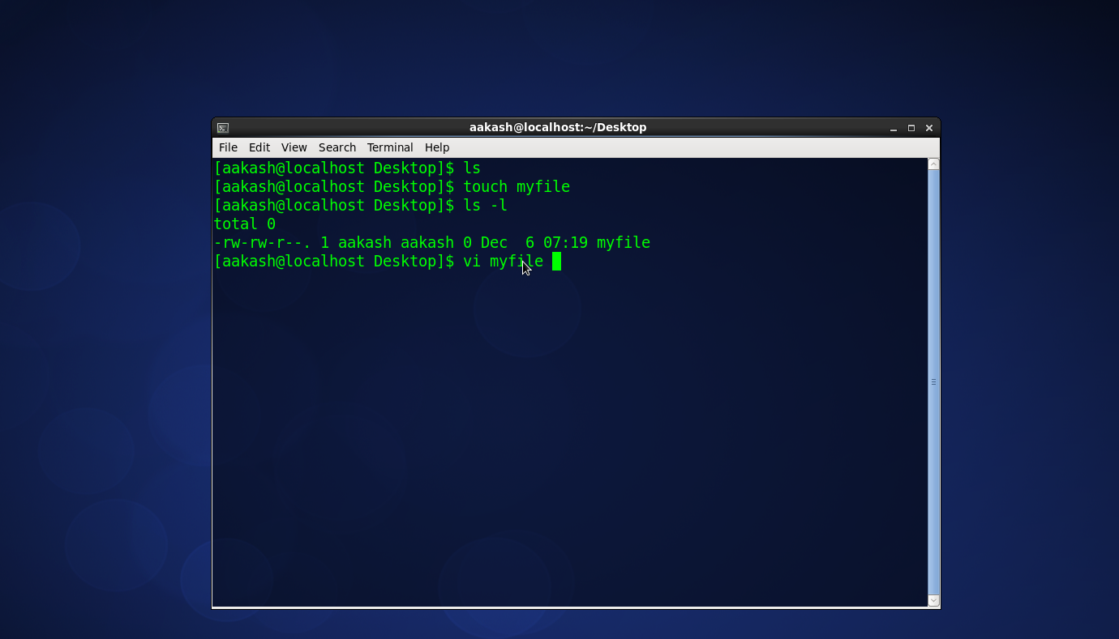

Answer 2.

Opening the File Using Vi Editor.



Step2 Output.

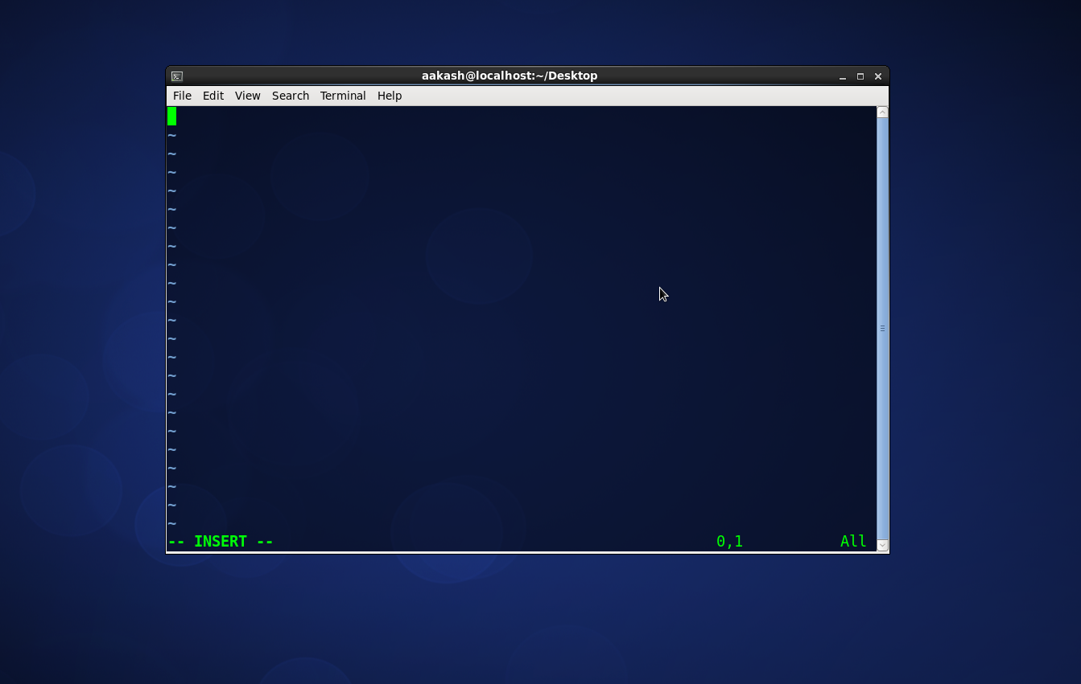

Answer 3.

Writing The Details And Saving It By Using: wq!

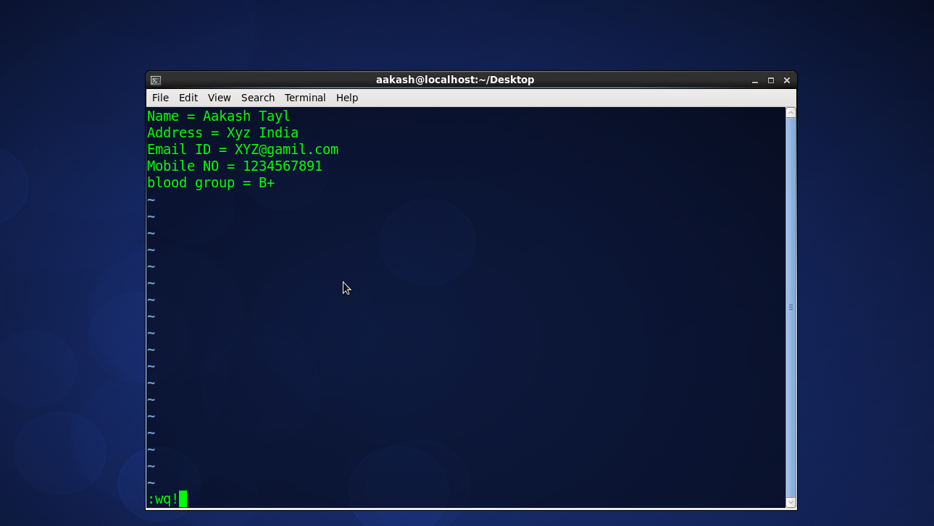

Then Opening it by using “cat command”.

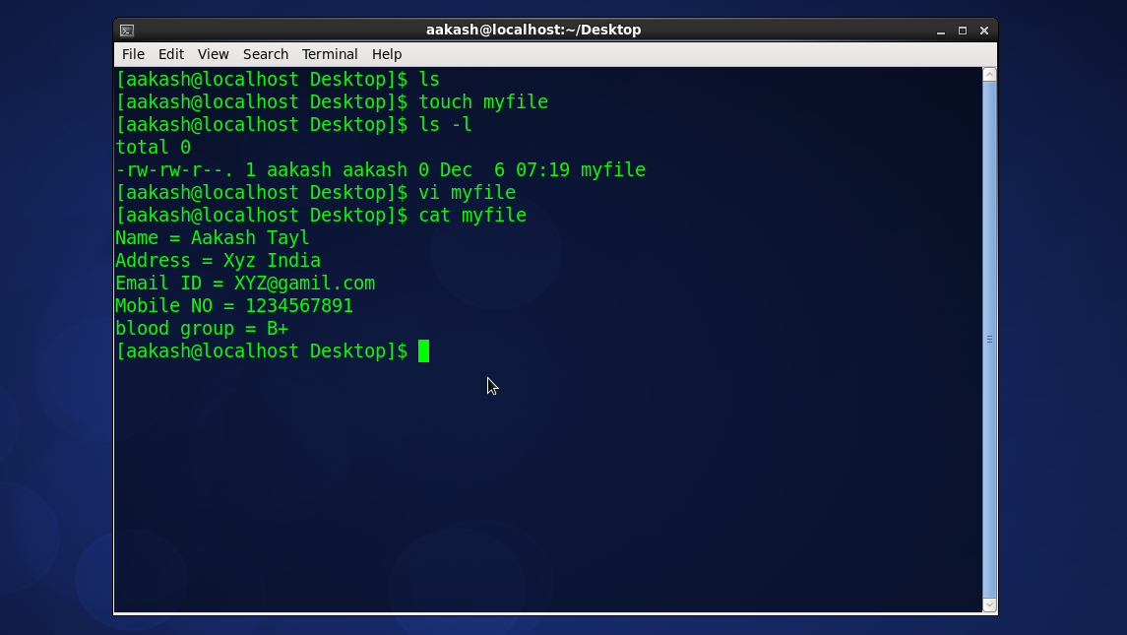

Showing one single expression to find the name and blood group line.

